**Integer Programming:** Whirlpool Corporation a major home appliance company is considering opening warehouses in four cities: New York, Los Angeles, Chicago, and Atlanta. Each warehouse can ship 15,000 units of refrigerators per week. The weekly fixed cost of keeping each warehouse open is $60,000 for New York, $50,000 for Los Angeles, $40,000 for Chicago, and $35,000 for Atlanta. The north-east region of the country requires 8000 units of refrigerators per week, the west region requires 9000 units per week, and the mid-west region requires 7000 units per week. The costs (including production and shipping costs) of sending one refrigerator from a warehouse to a region are shown in the table below. The company wants to meet weekly demands at minimum cost, subject to the preceding information and the following restrictions:

* If the New York warehouse is opened, then the Los Angeles warehouse must be opened.
* At most two warehouses can be opened.
* Either the Atlanta or the Los Angeles warehouse must be opened.

**Table:** Unit production and shipping costs



**Model**

**Decision Variables:**

$x_{ij}$: Units of refrigerators to be shipped from warehouse *i* to region *j*

{*i*: 1 = New York, 2 = Los Angeles, 3 = Chicago, 4 = Atlanta; *j*: 1 = North-East, 2 = West, 3 = Mid-West}

$y_{i}$: equals 1 if warehouse *i* is opened and equals 0 otherwise.

**Input Parameters:**

$R_{j}$: denotes requirement of refrigerators for region *j*.

$F_{i}$: denotes fixed cost to open warehouse *i*

$S_{ij}$: Cost to ship one refrigerator from warehouse *i* to region *j*

L: Weekly limit of refrigerators that can be shipped by each warehouse

**Objective:**

Total shipping cost: $\sum_{i=1}^{4}{\sum_{j=1}^{3}{S_{ij}x_{ij}}}$

Total cost of opening the warehouses: $\sum_{i=1}^{4}{F_{i}y_{i}}$

The objective of the company is to minimize the total shipping costs and the total cost of opening the warehouses. Thus, the objective function is as follows:

$$Minimize \sum_{i=1}^{4}{\sum_{j=1}^{3}{S_{ij}x_{ij}}}+\sum_{i=1}^{4}{F_{i}y_{i}}$$

**Constraints:**

1. Limit of Shipping for each warehouse that is opened
$$\sum_{j=1}^{3}{x_{ij}}≤L∙y_{i} ∀i$$

2. Requirement of refrigerators for each region
$$\sum_{i=1}^{4}{x_{ij}}≥R_{j} ∀j$$

3. At most two warehouses can be opened
$$\sum_{i=1}^{4}{y_{i}}≤2$$

4. If the New York warehouse is opened, then the Los Angeles warehouse must be opened.
$$y_{1}≤y_{2}$$

5. Either the Atlanta or the Los Angeles warehouse must be opened.
$$y_{2}+y_{4}≥1$$

6. Non-negativity and binary constraint

$$x_{ij}≥0 ∀i,j$$

$$y_{i}∈\left\{0, 1\right\} ∀i$$

**Optimal Solution**

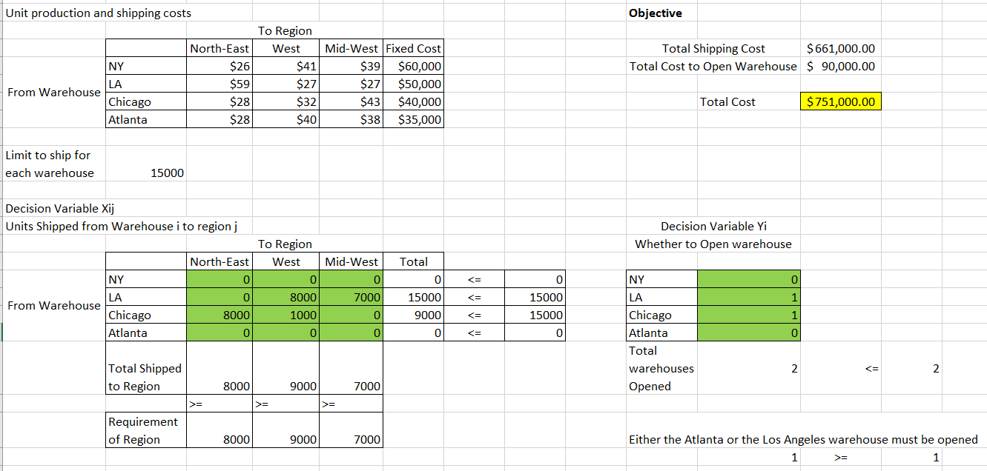

Whirlpool Corporation can satisfying the requirements of the 3 regions by opening warehouses in Los Angeles and Chicago with a total minimum cost of $751,000.